Aim

Set 21: Energy Consumption Analysis
Data Visualization using R

To analyse energy consumption data in R using a histogram, a density plot, a bubble scatter plot, a bar chart and a dashboard with filters.

Procedure
- Open RStudio and load the packages ggplot2 and gridExtra (install them once with install.packages(c("ggplot2", "gridExtra"))).
- Save the data as Energy_Consumption_Data.csv and import it with read.csv().
- Question 1: plot the histogram with geom_histogram() and the density curve with geom_density().
- Question 2: draw the scatter plot of temperature against units with bubble size = Peak_Hours and alpha for transparency.
- Question 3: find the average Renewable_Usage of each sector with aggregate() and draw the bar chart.
- Question 4: draw the monthly line chart and the Sector vs Region heatmap, join them into a dashboard, and apply the Month and Sector filters with subset().
- Run the code and note the output and the figures.

R Code
library(ggplot2); library(gridExtra) options(width = 95)

# Create the CSV file and import it data.frame(
Sector = c("Residential","Commercial","Industrial","Residential","Commercial","Industrial"), Region = c("North","South","West","East","North","South"),
Month = c("Jan","Jan","Feb","Feb","Mar","Mar"), Temperature = c(15, 24, 20, 18, 28, 30),
Units_Consumed = c(320, 540, 880, 350, 610, 920),
Cost = c(2100, 3600, 5900, 2300, 4100, 6200),
Renewable_Usage = c(22, 18, 12, 25, 20, 15),
Peak_Hours = c(4, 6, 8, 5, 7, 9)
) -> d
write.csv(d, "Energy_Consumption_Data.csv", row.names = FALSE) energy <- read.csv("Energy_Consumption_Data.csv")
energy$Month <- factor(energy$Month, levels = c("Jan","Feb","Mar")) print(energy)

# 1. Histogram and density plot print(aggregate(Units_Consumed ~ Sector, energy, mean)) p1 <- ggplot(energy, aes(Units_Consumed)) +
geom_histogram(aes(y = after_stat(density)), binwidth = 150, fill = "skyblue", colour = "white") + geom_density(colour = "red") +
labs(title = "Histogram and Density of Units Consumed", x = "Units Consumed (kWh)", y = "Density")

# 2. Scatter plot with bubble size and transparency
cat("Correlation:", cor(energy$Temperature, energy$Units_Consumed), "\n") p2 <- ggplot(energy, aes(Temperature, Units_Consumed, size = Peak_Hours))
+ geom_point(alpha = 0.5, colour = "blue") +
labs(title = "Temperature vs Units Consumed", x = "Temperature (C)", y = "Units Consumed (kWh)")

# 3. Average renewable usage by sector
avg <- aggregate(Renewable_Usage ~ Sector, energy, mean) print(avg)

p3 <- ggplot(avg, aes(Sector, Renewable_Usage, fill = Sector)) + geom_col(show.legend = FALSE) + geom_text(aes(label = paste0(Renewable_Usage, "%")), vjust = -0.5) +
labs(title = "Average Renewable Usage by Sector", y = "Renewable Usage (%)")

# 4. Dashboard (line chart + heatmap); filters are applied with subset() dash <- function(d, title) {
line <- ggplot(aggregate(Units_Consumed ~ Month, d, sum), aes(Month, Units_Consumed, group = 1)) + geom_line() + geom_point(size = 3) + labs(title = "Monthly Energy Usage", y = "Units (kWh)")
heat <- ggplot(d, aes(Region, Sector, fill = Units_Consumed)) + geom_tile() + geom_text(aes(label = Units_Consumed)) + scale_fill_gradient(low = "yellow", high = "red") + labs(title = "Heatmap: Sector vs Region", fill = "Units")
arrangeGrob(line, heat, ncol = 2, top = title)
}
d1 <- dash(energy, "Energy Dashboard (No Filter)")
d2 <- dash(subset(energy, Month %in% c("Jan","Feb") & Sector != "Industrial"), "Energy Dashboard (Filter: Jan-Feb, Residential and Commercial)")

ggsave("set21_q1.png", p1, width = 6, height = 4, bg = "white") ggsave("set21_q2.png", p2, width = 6, height = 4, bg = "white") ggsave("set21_q3.png", p3, width = 6, height = 4, bg = "white") ggsave("set21_q4a.png", d1, width = 12, height = 5, bg = "white") ggsave("set21_q4b.png", d2, width = 12, height = 5, bg = "white")

Output
e_Usage Peak_Hours
- Commercial 575
- Industrial 900
- Residential 335
Correlation: 0.654655
Sector Renewable_Usage 1 Commercial 19.0
- Industrial 13.5
- Residential 23.5

Sector Region Month Temperature 1 Residential North Jan 15 |  | Units_Consumed Cost Renew 320 2100 22 4 |  |  | abl
2 Commercial South Jan | 24 | 540 3600 | 18 |  | 6
3 Industrial West Feb | 20 | 880 5900 | 12 | 8
4 Residential East Feb | 18 | 350 2300 | 25 | 5
5 Commercial North Mar | 28 | 610 4100 | 20 |  | 7
6 Industrial South Mar Sector Units_Consumed | 30 | 920 6200 | 15 | 9

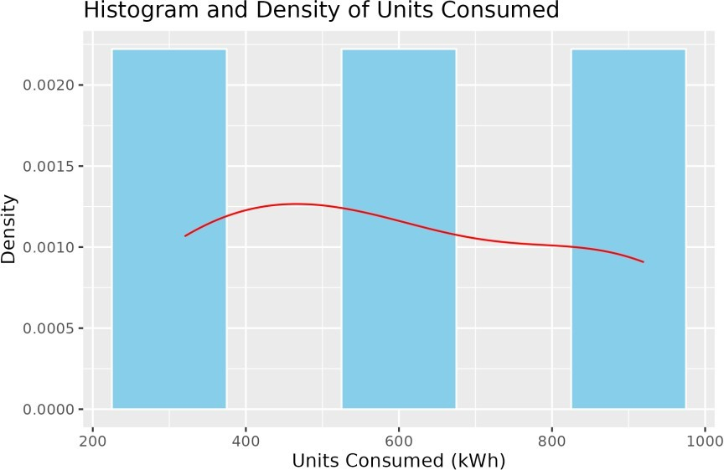

Figure 21.1: Q1 - Histogram and density plot

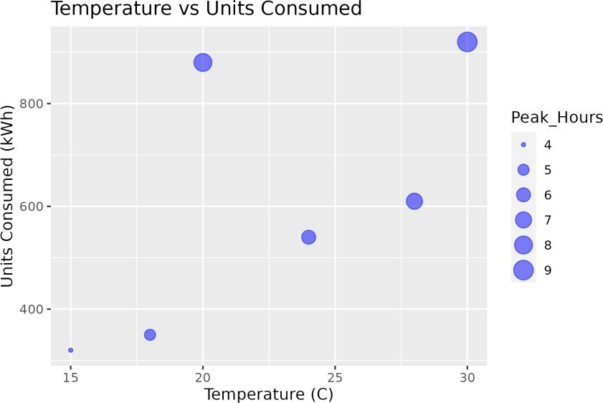
Figure 21.2: Q2 - Temperature vs units (bubble = peak hours)
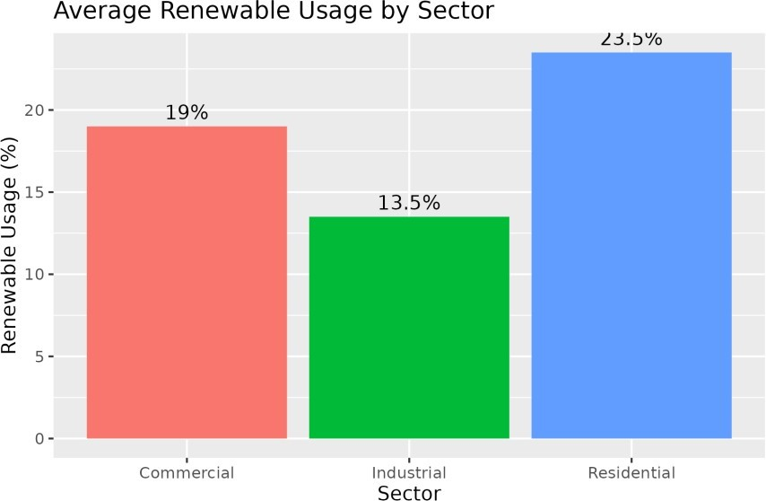

Figure 21.3: Q3 - Average renewable usage by sector
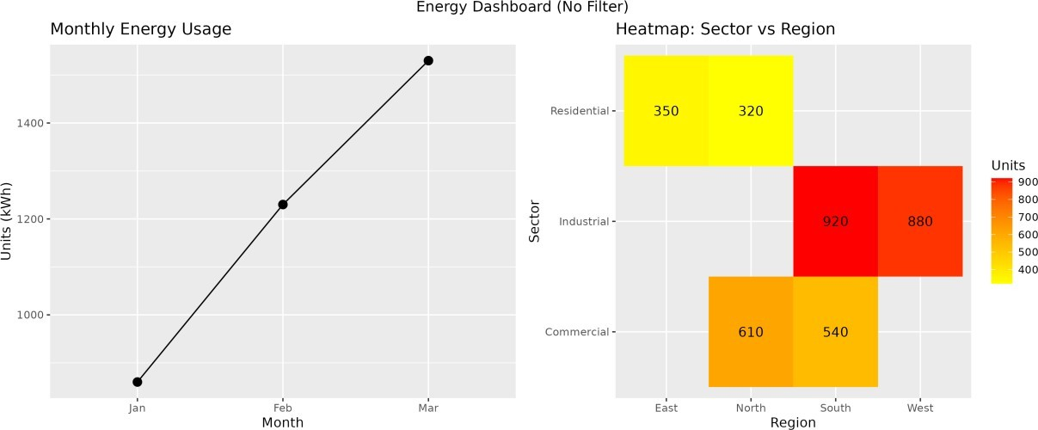

Figure 21.4: Q4 - Dashboard (no filter)

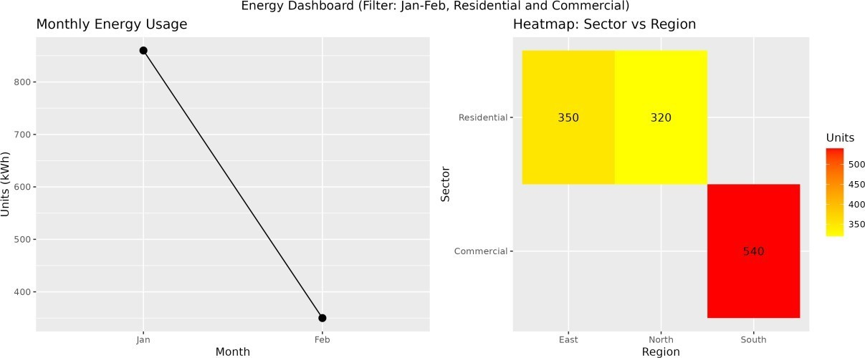
Figure 21.5: Q4 - Dashboard (filter: Jan-Feb, Residential and Commercial)

Result
- Industrial uses the most energy (average 900 kWh) and Residential the least (335 kWh).
- Temperature and units have a positive correlation of 0.65.
- Residential has the highest renewable usage (23.5%) and Industrial the lowest (13.5%), so Industrial has the most scope to improve.
- Energy use rises from January to March, and the heatmap shows the highest use in Industrial.

